Kingdom of Saudi Arabia  Ministry of Education  Eastern Province Education Department  Tarbeat Al-Ajial International Schools |  |  |  |  |  |  | Date: ……/………/..………  Subject: Computer  Grade: G6
……………… |  | Seat Number |  | ……………………………………….. |  |  |  | Student’s Name
Mid Term exam 2nd Semester 2026/2025
Sign. | Consultative Name |  | Sign. |  | Corrector’s Name | Marks in letters |  |  | Marks  in numbers
 |  |  |  |  |  |  |  |  | 20

Question A: write the correct name of each part.

Concept | Publish | Test | Design




Concept
…………………….
…………………….
…………………….
…………………….
Publish
Test
Design
Good Luck

Question B: write the correct name of each part.

Action | Arcade | Educational
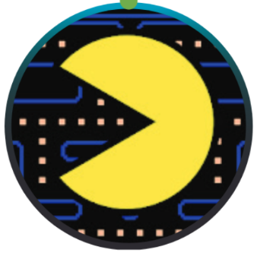
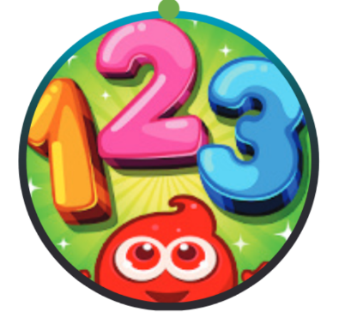

Arcade
Educational



Action

Question C: State whether the statements are (True/False).
- Sprites: A sprite is a 2-dimensional image used to visually represent an object.

- True b. False

- Behaviors: A behavior is a predefined set of actions that adds extra capabilities to the object.

- True b. False

